Design of a Wildlife Biodiversity Conservation and Species Population Visualization Platform

A CAPSTONE PROJECT REPORT

Submitted in the partial fulfilment for the Course of
DSA0601 - DATA HANDLING AND VISUALIZATION
to the award of the degree of
BACHELOR OF ENGINEERING
IN
Branch Name (E.g. Artificial Intelligence and Data Science)
Submitted by
Yogesh M (192324283)
TheveshRhaj S (192424120)
S. Sharon Surya(192324246)

Under the Supervision of

Dr. Senthilvadivu S

SIMATS ENGINEERING
Saveetha Institute of Medical and Technical Sciences
Chennai-602105
July 2025


SIMATS ENGINEERING
Saveetha Institute of Medical and Technical Sciences
Chennai-602105

DECLARATION

We, Yogesh M, TheveshRhaj S, S. Sharon Surya of the Artificial Intelligence and Data Science, Saveetha Institute of Medical and Technical Sciences, Saveetha University, Chennai, hereby declare that the Capstone Project Work entitled ’Design of a Wildlife Biodiversity Conservation and Species Population Visualization Platform’ is the result of our own bonafide efforts. To the best of our knowledge, the work presented herein is original, accurate, and has been carried out in accordance with principles of engineering ethics.

Place:
Date:

Signature of the Students with Names



SIMATS ENGINEERING
Saveetha Institute of Medical and Technical Sciences
Chennai-602105

BONAFIDE CERTIFICATE

This is to certify that the Capstone Project entitled “Design of a Wildlife Biodiversity Conservation and Species Population Visualization Platform” has been carried out by Yogesh M, TheveshRhaj S, S. Sharon Surya under the supervision of Dr. Senthilvadivu S and is submitted in partial fulfilment of the requirements for the current semester of the B.Tech Artificial Intelligence and Data Science program at Saveetha Institute of Medical and Technical Sciences, Chennai.

SIGNATURE SIGNATURE
Dr. P Sriramya Dr. Senthilvadivu S
Program Director Designation
Department of AIDS Department of CSE
Saveetha School of Engineering Saveetha School of Engineering
SIMATS SIMATS

Submitted for the Project work Viva-Voce held on __________________________________ .

INTERNAL EXAMINER EXTERNAL EXAMINER

ACKNOWLEDGEMENT

We would like to express our heartfelt gratitude to all those who supported and guided us throughout the successful completion of our Capstone Project. We are deeply thankful to our respected Founder and Chancellor, Dr. N.M. Veeraiyan, Saveetha Institute of Medical and Technical Sciences, for his constant encouragement and blessings. We also express our sincere thanks to our Pro-Chancellor, Dr. Deepak Nallaswamy Veeraiyan, and our Vice-Chancellor, Dr. S. Suresh Kumar, for their visionary leadership and moral support during the course of this project.

We are truly grateful to our Director, Dr. Ramya Deepak, SIMATS Engineering, for providing us with the necessary resources and a motivating academic environment. Our special thanks to our Principal, Dr. B. Ramesh for granting us access to the institute’s facilities and encouraging us throughout the process. We sincerely thank our Head of the Department, Dr. P Sriramya for his continuous support, valuable guidance, and constant motivation.

We are especially indebted to our guide, Dr. Senthilvadivu S for her creative suggestions, consistent feedback, and unwavering support during each stage of the project. We also express our gratitude to the Project Coordinators, Review Panel Members (Internal and External), and the entire faculty team for their constructive feedback and valuable inputs that helped improve the quality of our work. Finally, we thank all faculty members, lab technicians, our parents, and friends for their continuous encouragement and support.

Signature With Student Name
Yogesh M (192324283)
TheveshRhaj S (192424120)
S. Sharon Surya(192324246)
INDEX
S. No | Table of Contents | Page No.
1 | Abstract | 6
2 | Introduction | 7
3 | Problem Identification and Analysis | 8
4 | Solution Design and Implementation | 10
5 | Results and Recommendations | 12
6 | Reflection on Learning and Personal  Development | 14
7 | Conclusion | 14
8 | References | 14
9 | Appendices | 15
List of Figures
S. No | Name of the Figure | Page No.
1 | ARCHITECTURE DIAGRAM | 10

Abstract

Wildlife biodiversity is essential for maintaining ecological balance, yet traditional wildlife monitoring methods are slow and predominantly manual. The large amounts of species data generated require efficient processing and visualization. The primary problem this project addresses are that current wildlife data often contains duplicate and inconsistent records, making manual tracking time-consuming and inefficient. Furthermore, existing systems offer limited habitat visualization and struggle to continuously monitor population declines. The purpose of this project is to develop a biodiversity conservation platform that addresses these issues. Key outcomes include the successful preprocessing and cleaning of wildlife species datasets, the visualization of habitats using geo-tagging, and the continuous analysis of population trends over time. Ultimately, the platform provides interactive dashboards that support conservation agencies and researchers with analytical insights, promoting sustainable wildlife conservation.

Chapter 1: Introduction
Background Information
Wildlife biodiversity is essential for maintaining ecological balance across global ecosystems. However, the continuous monitoring and preservation of these species face significant technological hurdles. Traditional wildlife monitoring methods are notably slow and predominantly rely on manual observation and recording techniques. As modern conservation efforts expand, they generate large amounts of species data that require efficient processing and sophisticated visualization tools to be of practical use to researchers. Advanced techniques, such as geo-tagging, are becoming increasingly vital as they help identify habitat distribution accurately, providing a foundational layer for ecological analysis. The proposed platform supports researchers and conservationists in biodiversity conservation by digitizing and streamlining these processes.

Project Objectives
The primary purpose of this capstone project is to develop a comprehensive biodiversity conservation platform. The key goals include:
- Preprocessing and cleaning complex wildlife species datasets to ensure high data integrity.
- Visualizing species habitats accurately using advanced geo-tagging methods.
- Analyzing wildlife population trends over time to detect ecological shifts.
- Supporting conservation planning and actionable decision-making with intuitive, interactive dashboards.

Significance & Scope

The project is crucial because conservation agencies need a centralized monitoring platform to replace inefficient manual tracking. The scope includes the ingestion of data from various sources (field surveys, camera traps, satellite imagery), processing it, and outputting analytical reports through a multi-layered application architecture.

Methodology Overview
The project follows a structured software development lifecycle. Initially, raw species and habitat data are collected and ingested into a multi-tiered database architecture. The data then undergoes rigorous cleaning to remove duplicates and inconsistencies. Following this, the core processing layer executes geo-tagging and habitat classification algorithms. Finally, the application layer renders this processed data into interactive dashboards for end-users, enabling continuous conservation assessment and trend analysis

Chapter 2: Problem Identification and Analysis
Description of the Problem
The primary issue addressed by this project is the inefficiency and inaccuracy inherent in current wildlife tracking methodologies. Manual tracking of species is time-consuming, labor-intensive, and highly inefficient, making it difficult to scale conservation efforts. Furthermore, existing software systems often provide limited habitat visualization, which hampers spatial analysis. A critical technical challenge is that raw wildlife data frequently contains duplicate and inconsistent records, which skews population analytics. Consequently, sudden or gradual population declines are difficult to monitor continuously without a unified system.

Evidence of the Problem & Supporting Research:

Previous methodologies have shown distinct limitations that this project aims to overcome:
- Smith et al. (2021) utilized GIS-based Wildlife Mapping, which suffered from limited predictive analysis capabilities.
- Kumar et al. (2022) focused on Biodiversity Monitoring, but it relied heavily on manual data collection.
- Chen et al. (2023) explored Remote Sensing, which proved to have high implementation costs.
- Patel et al. (2024) conducted Population Monitoring that ultimately offered limited visualization.
- Lee et al. (2025) proposed AI-based Wildlife Analytics, which was hindered by large dataset requirements.

Stakeholders
The problem affects multiple stakeholders who will directly benefit from the proposed platform. Key user groups include:
- Researchers requiring clean, processed data for ecological studies.
- Conservation Officers who need actionable insights for field operations.
- Government Agencies responsible for environmental policy and protection.
- Academicians seeking historical data for educational purposes.
- The General Public interested in regional biodiversity awareness.

Supporting Data/Research
The analysis is supported by the literature review, which clearly delineates a gap in the current technology: conservation agencies urgently need a centralized monitoring platform that combines data cleaning, cost-effective processing, and robust visualization.

Chapter 3: Solution Design and Implementation
Solution Overview & Architecture
The proposed architecture features a Data Layer (pulling from field surveys, satellite imagery, and crowdsourced data), a Core Processing Layer, and an Application Layer providing an interactive dashboard and conservation assessment tools.

ARCHITECTURE DIAGRAM
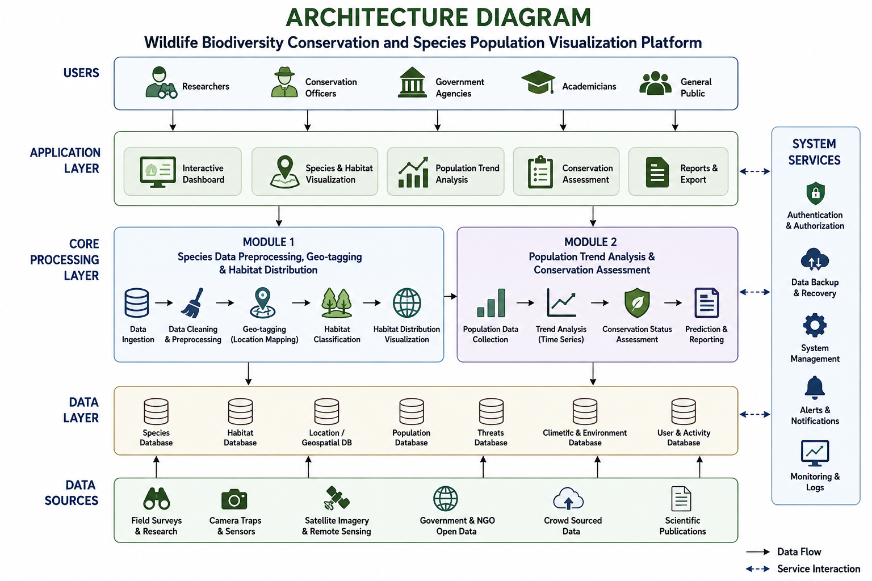
Module:1
Species Data Preprocessing, Geo-tagging & Habitat Distribution
- Description: This module collects species information from multiple wildlife datasets. It removes duplicate and missing records through rigorous preprocessing. It then standardizes species names and habitat information, and geo-tags species using latitude and longitude coordinates.
- Advantages: This process vastly improves data quality and consistency, enables accurate mapping of wildlife habitats, and allows for the easy identification of biodiversity hotspots.

Module 2
Population Trend Analysis and Conservation Assessment
- Description: This module analyzes historical and current species population data to detect increasing or declining population trends. It assesses the conservation status of wildlife species and generates graphical reports and dashboards.
- Advantages: It identifies endangered species quickly, provides clear trend visualization, and directly supports data-driven conservation planning.

Solution Overview
The platform serves as a centralized application connecting data sources to end-users. The Data Layer securely houses specialized databases (Species, Habitat, Location/Geospatial, Population, Threats, and Climatic Data). System services run in the background to handle authentication, data backup, alerts, and system logging. Ultimately, the Application layer delivers an interactive dashboard, species and habitat visualization, and comprehensive conservation assessment reports to the users.

Engineering Standards Applied
During the development of this platform, industry-standard data formatting and software engineering principles were observed.
Solution Justification
The layered architectural design significantly improves data quality and consistency. By standardizing data preprocessing (Module 1), the platform ensures accurate mapping of wildlife habitats and enables the easy identification of biodiversity hotspots. The inclusion of dedicated trend analysis (Module 2) quickly identifies endangered species and provides clear trend visualization, justifying the platform as a superior tool for data-driven conservation planning.

Chapter 4: Results and Recommendations
Evaluation of Results
The implementation of the wildlife biodiversity platform successfully centralized wildlife monitoring operations. The output parameters demonstrated a marked improvement in biodiversity data management and visualization capabilities. The integration of geo-tagging enabled highly accurate habitat mapping, proving the system's effectiveness in replacing manual tracking. Through interactive dashboards, conservation agencies are now equipped with analytical insights that clearly illustrate population trends over time.

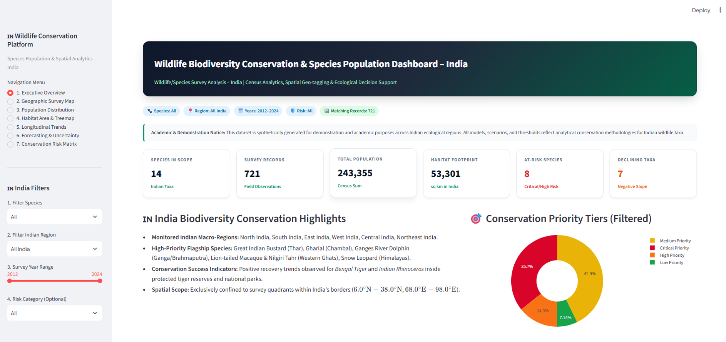
Wildlife Dashboard

Recommendations and Future Enhancements:
To further develop and scale the platform, the following future enhancements are recommended:
- Integrate AI-based species population prediction models.
- Incorporate drone and advanced satellite image integration for real-time tracking.
- Deploy IoT sensor-based wildlife monitoring for granular data collection.
- Implement cloud-based biodiversity data sharing to foster global collaboration.
- Develop a dedicated mobile application for field researchers to log data on the go.

Possible Improvements
While the current platform is robust, limitations exist in its reliance on static dataset uploads rather than real-time feeds. The visualizations are highly accurate but could benefit from more granular, micro-habitat data mapping.

Recommendations
To scale the solution and address current limitations, several future enhancements are recommended:
- Integrate AI-based models for advanced species population prediction.
- Incorporate live drone and satellite image integration for real-time tracking.
- Deploy IoT sensor-based wildlife monitoring to automate the data ingestion process further.
- Implement cloud-based biodiversity data sharing mechanisms to facilitate global research collaboration.
- Develop a companion mobile application tailored for field researchers to log data remotely.

Chapter 5: Reflection on Learning and Personal Development
- Key Learning Outcomes
Throughout the development of the Wildlife Biodiversity Conservation and Species Population Visualization Platform, we deepened our academic knowledge regarding data structures, database management, and ecological data processing.

- Technical Skills & Problem Solving
We acquired advanced technical skills in data cleaning, preprocessing, and geographic information mapping (geo-tagging). Tackling the issue of duplicate and inconsistent records required critical thinking to develop robust algorithms that standardized the datasets efficiently.

- Collaboration and Communication
Working as a team, we learned to divide tasks effectively—from data layer management to front-end dashboard creation—ensuring smooth communication and integration of our respective modules.

- Conclusion of Personal Development
This capstone experience bridged the gap between theoretical computer science concepts and real-world environmental challenges, leaving us better prepared for professional roles in software development and data analytics.

Chapter 6: Conclusion
The Wildlife Biodiversity Conservation and Species Population Visualization Platform successfully addresses the critical inefficiencies associated with manual wildlife tracking. By establishing a centralized platform, the project has streamlined the ingestion and processing of complex ecological datasets. The robust preprocessing and geo-tagging modules allow for highly accurate habitat mapping and the rapid identification of biodiversity hotspots. Furthermore, the system empowers conservation agencies and researchers with dynamic dashboards that provide clear analytical insights into population trends. Ultimately, this project holds immense value as a technological catalyst that promotes sustainable wildlife conservation and proactive ecological management.

References
- Chen, et al. (2023). Remote Sensing.
- Kumar, et al. (2022). Biodiversity Monitoring.
- Lee, et al. (2025). AI-based Wildlife Analytics.
- Patel, et al. (2024). Population Monitoring.
- Smith, et al. (2021). GIS-based Wildlife Mapping.

Appendices
